StreamForge – Visual Data Pipeline Orchestration Platform

Submitted By: - Abhinav R Nair
Guide: - Mrs. Divya R
Date: - 12th Jan 2026
SYNOPSIS
The primary objective of StreamForge is to democratize data engineering by providing a visual, drag-and-drop interface for building complex data pipelines (ETL workflows). In the current data-driven landscape, processing data often requires specialized coding skills in languages like Python or SQL. StreamForge bridges this gap, creating a seamless, centralized digital platform that enhances productivity for both technical and non-technical users.
The system allows users to ingest data from various sources (CSV, Excel, JSON), perform transformations (filtering, joining, cleaning), and visualize or export the results—all without writing a single line of code. For administrators and teams, it offers robust user management, automated scheduling of workflows, and real-time collaboration tools. By integrating AI assistance (Gemini), StreamForge further simplifies debugging and pipeline optimization, ensuring that data workflows are efficient, accessible, and scalable.

EXISTING SYSTEM
Currently, organizations and students rely on two main approaches for data processing, both of which have significant limitations:
- Manual Scripting (Python/Pandas/SQL):
  - Users write custom scripts to process data.
  - Drawback: This requires a steep learning curve and high technical expertise. Scripts are often difficult to maintain, share, or debug by others.
- Enterprise ETL Tools (e.g., Alteryx, Informatica):
  - These are powerful but extremely expensive and resource-heavy.
  - Drawback: They are often inaccessible to smaller teams, students, or individual developers due to licensing costs and complex installation requirements.
Drawbacks of the Existing System:
- High Technical Barrier: Requires coding knowledge.
- Lack of Collaboration: Scripts live on local machines; sharing logic is difficult.
- Poor Maintainability: "Spaghetti code" is hard to debug.
- Cost: Enterprise solutions are prohibitively expensive.
- No Integrated AI: Debugging requires manual searching and expertise.

PROPOSED SYSTEM (StreamForge)
StreamForge is a next-generation, web-based Visual Data Pipeline Platform designed to overcome the limitations of manual coding and expensive enterprise tools. It provides a "No-Code/Low-Code" environment where users visually chain together nodes to process data.
It addresses issues of accessibility by offering a React-based interactive canvas. It introduces modern features such as AI-powered assistance, Real-time Collaboration (similar to Google Docs), and Automated Scheduling (Cron jobs).
Advantages:
- Visual Interface: Drag-and-drop builder makes logic easy to understand.
- Web-Based: Accessible from any browser without complex local setups.
- Collaboration: Users can share pipelines with "Viewer" or "Editor" roles.
- AI Integration: Integrated chatbot helps explain errors or suggest transformations.
- Automated Scheduling: Pipelines can run automatically at set intervals.

MODULE DESCRIPTION
The project is modularized to ensure scalability and maintainability.
1. User Management Module
- Handles user registration, login (JWT authentication), and profile management.
- Tracks user statistics, such as total data processed.
- Includes distinct roles for Admins (system oversight) and Users (pipeline creators).
2. Pipeline Builder Module (Frontend)
- The core workspace where users drag nodes (Source, Filter, Join, Destination) onto a canvas.
- Manages the visual graph state using React Flow.
- Handles real-time validation of connections between data nodes.
3. Execution Engine Module (Backend)
- The "Brain" of the system. It parses the visual graph (JSON structure) sent from the frontend.
- Uses Pandas to execute the actual data transformations in memory.
- Generates logs and error reports for every execution run.

4. Collaboration & Sharing Module
- Allows users to share their pipelines with other registered users.
- Manages permissions (Read-only vs. Edit access).
- Facilitates teamwork on complex data projects.
5. Scheduling & Automation Module
- Integrated with APScheduler to handle background tasks.
- Allows users to define schedules (e.g., "Run every morning at 9 AM") for their pipelines.

FEASIBILITY STUDY
A feasibility study ensures the project is viable technically, economically, and socially.
1. Technical Feasibility:
- Stack: The project uses standard, robust technologies—React (Vite) for the frontend and Python (Flask) for the backend.
- Scalability: Docker and Containerization allow the system to be deployed easily on cloud platforms (AWS/GCP).
- Data Handling: Pandas is a proven industry standard for efficient data manipulation.
- Conclusion: The project is technically feasible using current web standards.
2. Economic Feasibility:
- Cost-Effectiveness: Built using open-source technologies (Python, React, SQLite), eliminating licensing costs.
- Efficiency: Drastically reduces the time required to build data pipelines compared to writing code from scratch.
- Conclusion: The system is economically viable and high-value.
3. Social/Operational Feasibility:
- User Adoption: The intuitive visual interface lowers the entry barrier, making it easy for students and analysts to adopt.
- Community: Facilitates knowledge sharing through pipeline sharing features.
- Conclusion: The system addresses a genuine need for easier data tools.

DATABASE TABLES
1)User
Field name | Datatype | Constraints | Description
user_id | INTEGER | Primary Key, Auto Increment | Unique user ID
username | VARCHAR(64) | Unique, Not Null, Index | User's login username
email | VARCHAR(120) | Unique, Not Null, Index | User's email address
password_hash | VARCHAR(128) | Not Null | Hashed password for security
is_admin | BOOLEAN | Default False | Administrative privileges
is_suspended | BOOLEAN | Default False | Account suspension status
total_processed_bytes | INTEGER | Default 0 | Total data processed by user

2) Data Source
Field name | Datatype | Constraints | Description
data_id | INTEGER | Primary Key, Auto Increment | Unique file ID
filename | VARCHAR(140) | Not Null | Original name of uploaded file
file_type | VARCHAR(20) | Not Null | File format (CSV, JSON, etc.)
file_size | VARCHAR(20) | Not Null | Human-readable file size
filepath | VARCHAR(200) | Not Null | Path to file on server
upload_date | DATETIME | Default Current Timestamp | Date of upload
user_id | INTEGER | Foreign Key → User | Owner of the file
3)Pipeline
Field name | Datatype | Constraints | Description
pipeline_id | INTEGER | Primary Key, Auto Increment | Unique pipeline ID
name | VARCHAR(140) | Not Null | Name of the pipeline project
structure | TEXT | Not Null | JSON string of nodes & edges
status | VARCHAR(20) | Default 'Ready' | Current state of the pipeline
created_at | DATETIME | Default Current Timestamp | Creation date and time
user_id | INTEGER | Foreign Key → User | Creator of the pipeline
schedule | VARCHAR(50) | Nullable | Cron string for automation
next_run | DATETIME | Nullable | Scheduled time for next run

4) Pipeline Run
Field name | Datatype | Constraints | Description
run_id | INTEGER | Primary Key, Auto Increment | Unique execution ID
pipeline_id | INTEGER | Foreign Key → Pipeline | The pipeline being executed
status | VARCHAR(20) | Default 'Running' | Outcome (Success/Failed)
start_time | DATETIME | Default Current Timestamp | Execution start time
end_time | DATETIME | Nullable | Execution completion time
logs | TEXT | Nullable | JSON logs of the execution

5) Shared Pipeline
Field name | Datatype | Constraints | Description
shared_id | INTEGER | Primary Key, Auto Increment | Unique share record ID
pipeline_id | INTEGER | Foreign Key → Pipeline | The pipeline being shared
user_id | INTEGER | Foreign Key → User | User receiving access
role | VARCHAR(20) | Default 'viewer' | Permission level (viewer/editor)

6) Processed File
Field name | Datatype | Constraints | Description
processed_id | INTEGER | Primary Key, Auto Increment | Unique output file ID
filename | VARCHAR(140) | Not Null | Name of the generated file
file_type | VARCHAR(20) | Not Null | Output format
file_size_display | VARCHAR(20) | Not Null | Human-readable size string
file_size_bytes | INTEGER | Not Null | Exact size in bytes
filepath | VARCHAR(200) | Not Null | Storage path for output
created_at | DATETIME | Default Current Timestamp | Time of generation
user_id | INTEGER | Foreign Key → User | Owner of the processed data

Level – 0 DFD
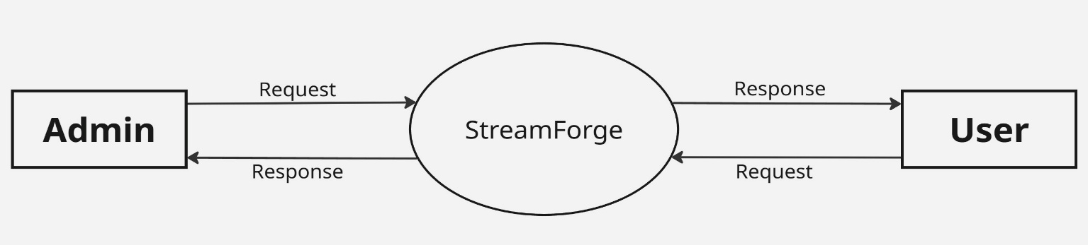

Level – 1 DFD (User)
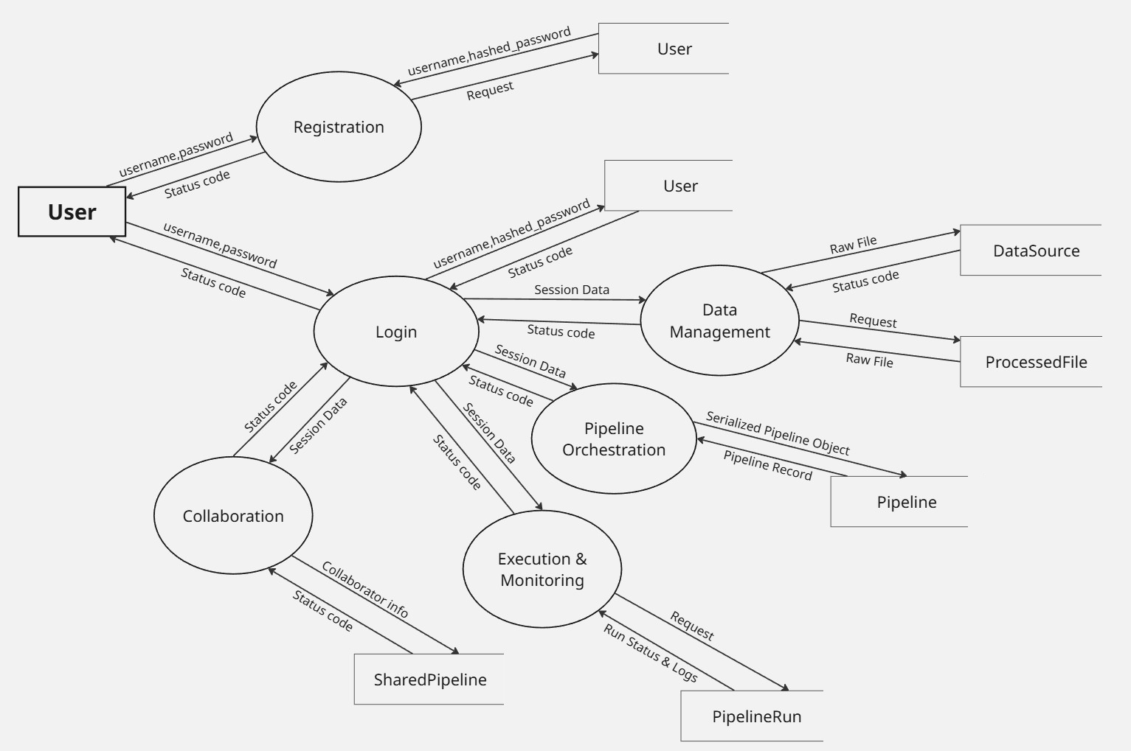

Level – 1 DFD (Admin)
